**ACKNOWLEDGEMENT**

To complete this project, many things are needed like our hard work as well as the supporting of many people.

First and foremost, we would like to express our heartfelt thanks to all who give us valuable advices and information towards the success of this project. We are thankful to **Dr. Zaw Htun** (Pro-rector), the Principle of Computer University (Sittway), for giving the permission to develop project.

We would like to mention deeply and special thanks to our supervisor, **Dr. Thu Thu Zan**, Associate Professor, Faculty of Computer Science, Computer University, Sittway for valuable guidance, supervision, encouragement and useful information during the preparation of this project.

We would like to express our gratitude to **Daw Hnin Thidar Kyaw (**Co-supervisor**)** for giving advices and helping in organizing project book.

Finally, we would like to thank to each group member (**Mg Htun Soe Hsan, Ma Su Su Lin, Ma Hnin Thandar Htun, Ma Shwe Eain San)** who participated in this work.

**ABSTRACT**

Nowadays, Online Shopping is becoming more and more popularity among people. Therefore, the project, Online Market Place called OMP is intended to develop Online Shopping. The major aims of OMP are to save time, energy for people and reduce costs for rent. Customer who has the internet connection can do shopping at one place. Our system has three roles- User role, Shop admin role, and Web admin role. In User roles, user can view, order easily about the products. Shop owners can register to rent the shop. In Shop admin role, the new products can be added and deleted, can be advertised the products for promotion and can be delivered by the owner. Customers can buy and view the products in market place.

**OBJECTIVES**

The objectives of the project are

* To support for shop owners to sell their products using online
* To help registration for shop owners via online
* To reduce many shops areas and rent costs for shop owners
* To provide the customers who can buy the products at one place
* To save energy and waste times for customers
* To buy the products easily and quickly without going outside

**WEB DESIGN**

This is OMP Web Design which includes “OMP” Button, “SHOPS” Button, “PRODUCTS” Button, “PROMOTION” Button, “POPULAR” Button, “LOGIN” Button, “BE SHOP” Button and “REPORT” Button.

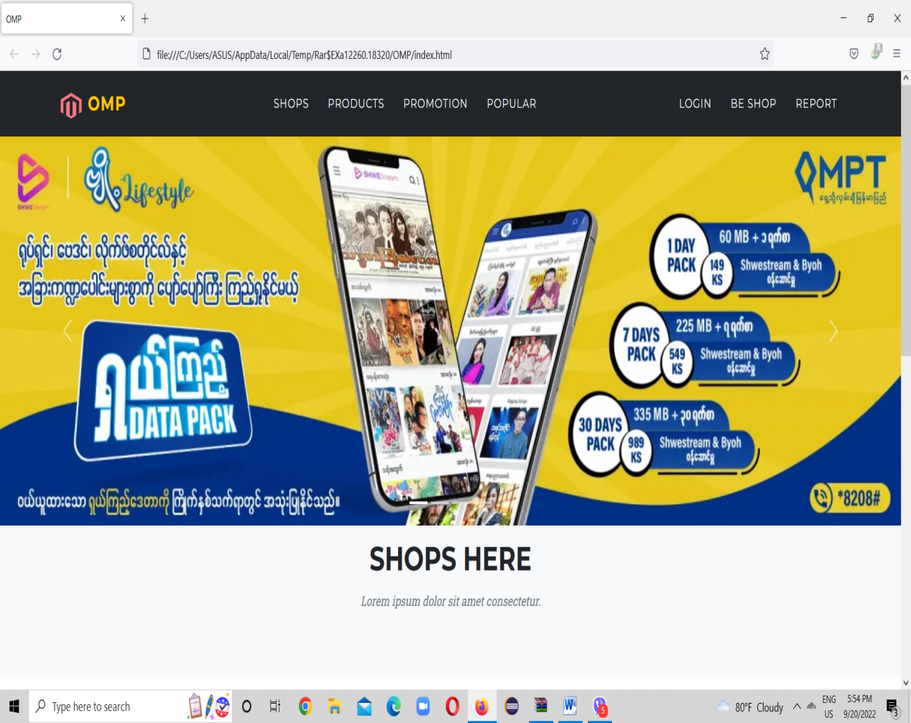

**Figure(1) : Web Design**

**IMPLEMENTATIONS**

**(1) User’s Home Page**

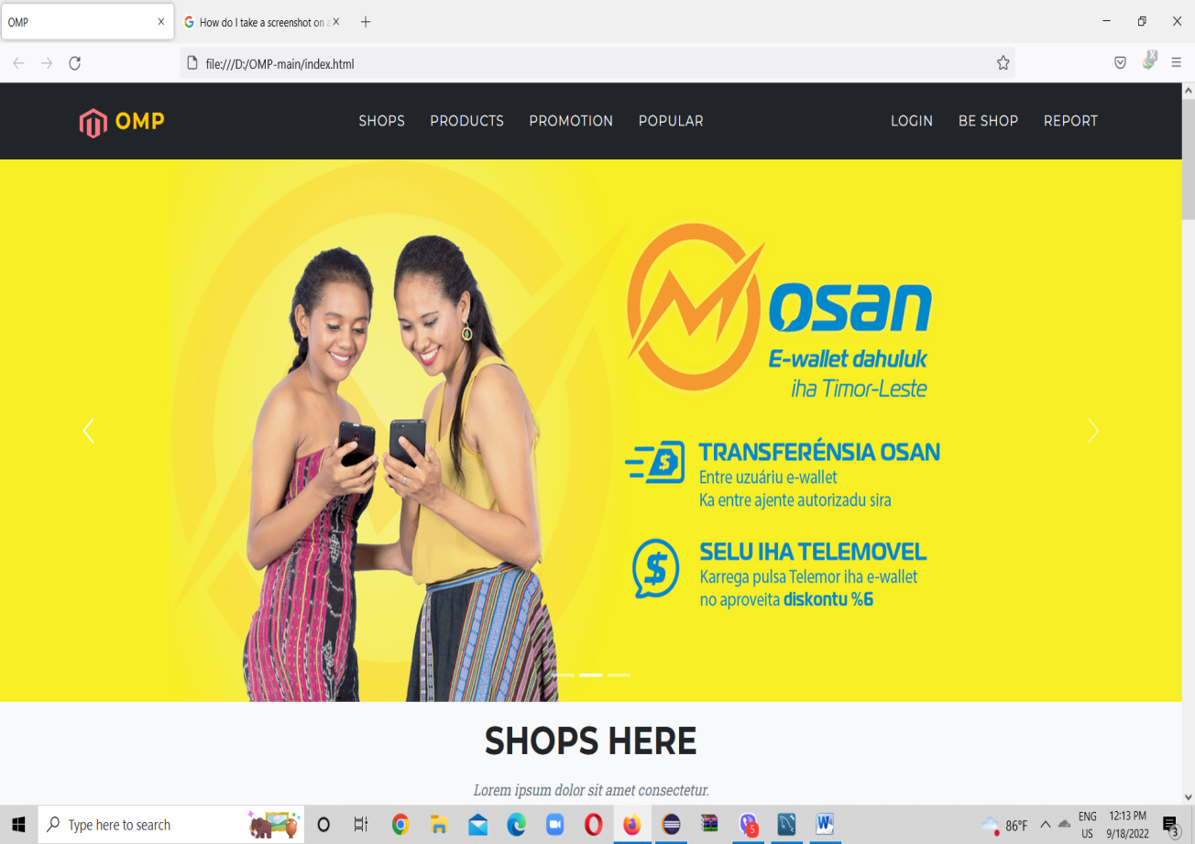 This is Homepage of this website and user can view the informations of our system. On the website, there are eight buttons such as **OMP**, Shops, Products, Promotion, Popular, Login, Be Shop and Report. Click the **OMP** of menu bar to reach home page.

**Figure(1.1) : Customer Home Page**

**(2) Shops Page**

When user or customer clicks Shops Button, many shops as shown in Figure (2.1) are displayed in this page. Customer can view the products and information of each shop.

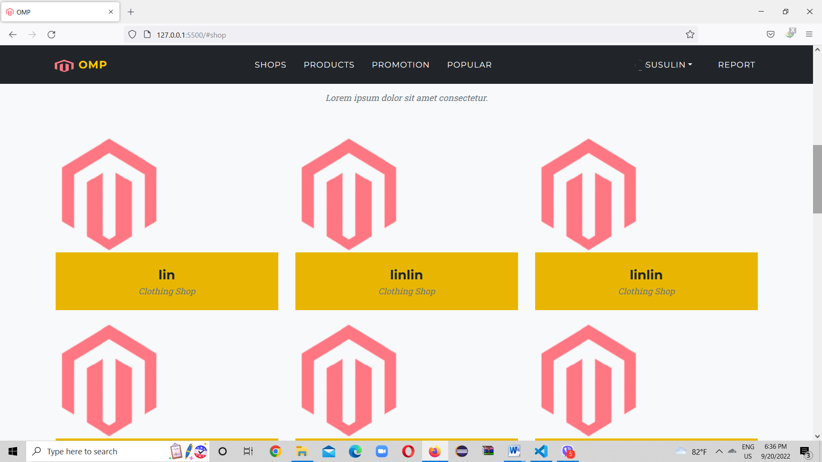

**Figure(2.1) : Shops Page**

**(3) Product Page**

When user or customer clicks the Product Button, they view every product in each shop. Each product has three buttons-View, Order and Cart. The View Button shows the shop concerning with this product.

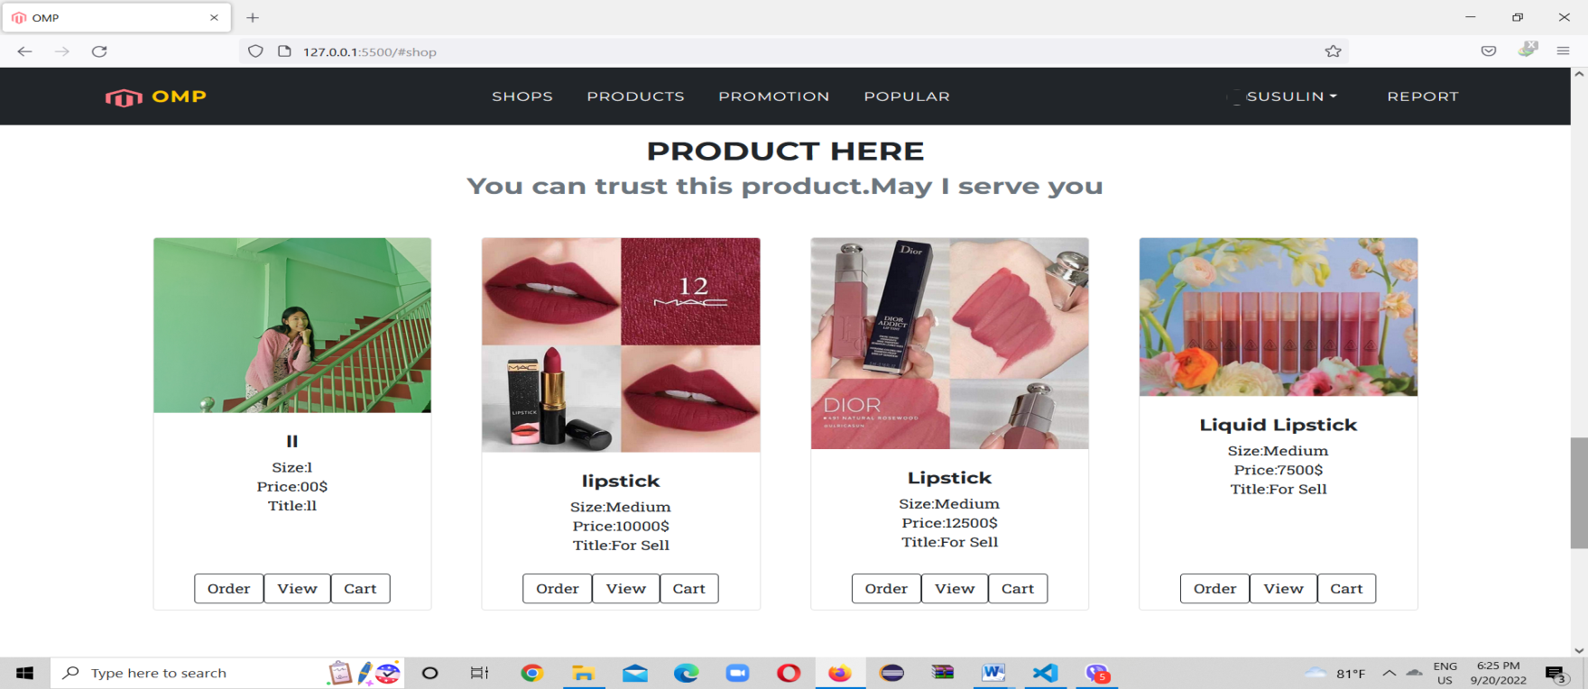**Figure(3.1) : Product Page**

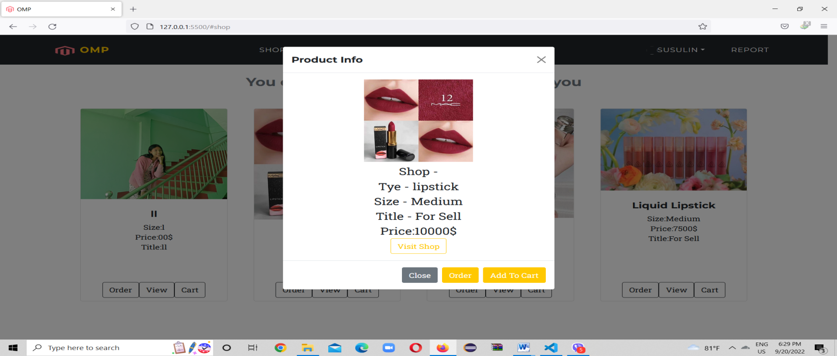If user or customer clicks the View Button, the specific facts are descriped.

**Figure(3.2) : View Button**

**(4) Promotion Page**

When user or customer clicks the Promotion Button, the available promotion products are shown as the following Figure (4.1).

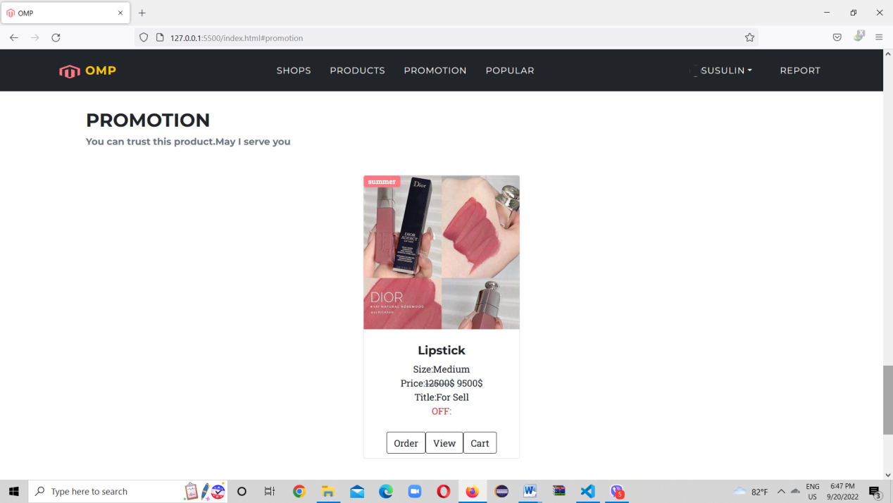**Figure(4.1) : Promotion Page**

**(5) Login Page**

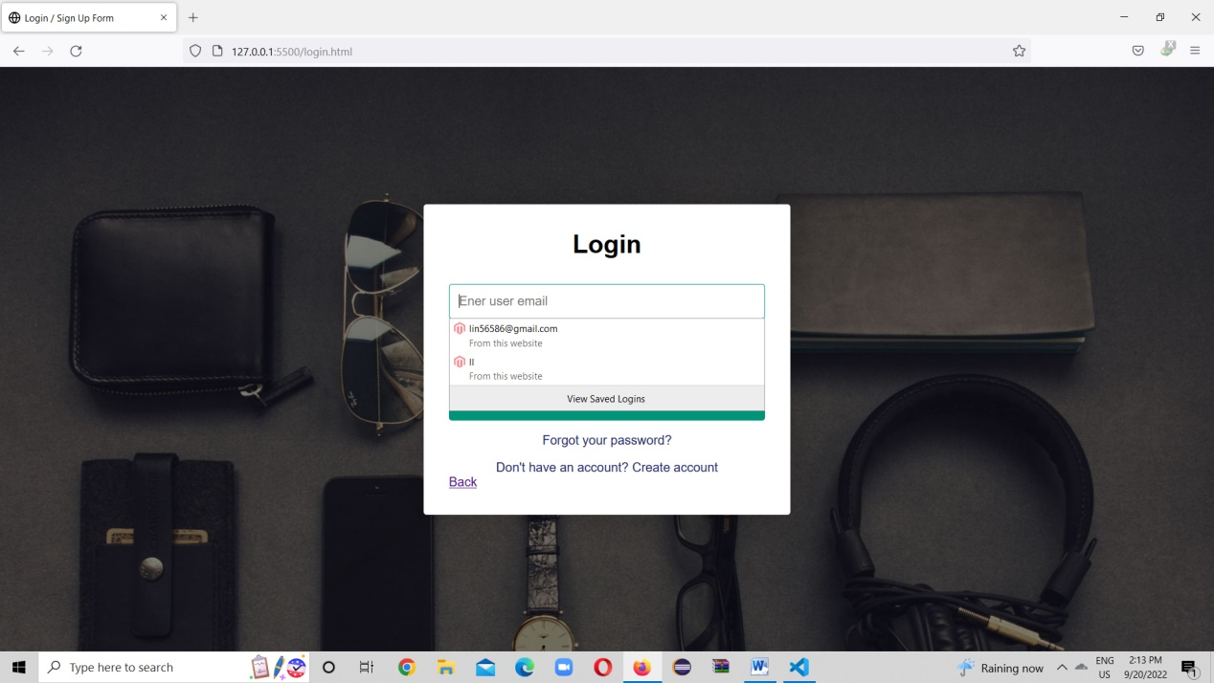When user or customer clicks the Login Button, the customer will see the login form. If the customer already has account, they can directly login as shown in Figure (5.1) .

**Figure(5.1): Login Page**

If the customer has no account, they can create new account as shown in Figure (5.2).

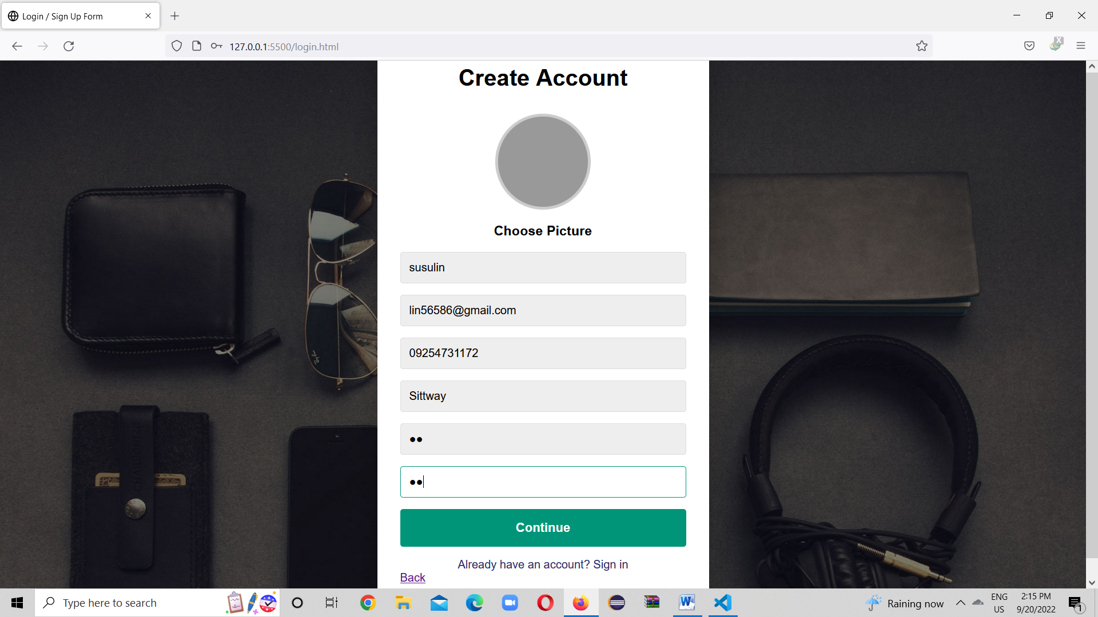

**Figure(5.2) : Create Account Form**

After the customer register and login, the customer gets a profile as shown in Figure (5.3).

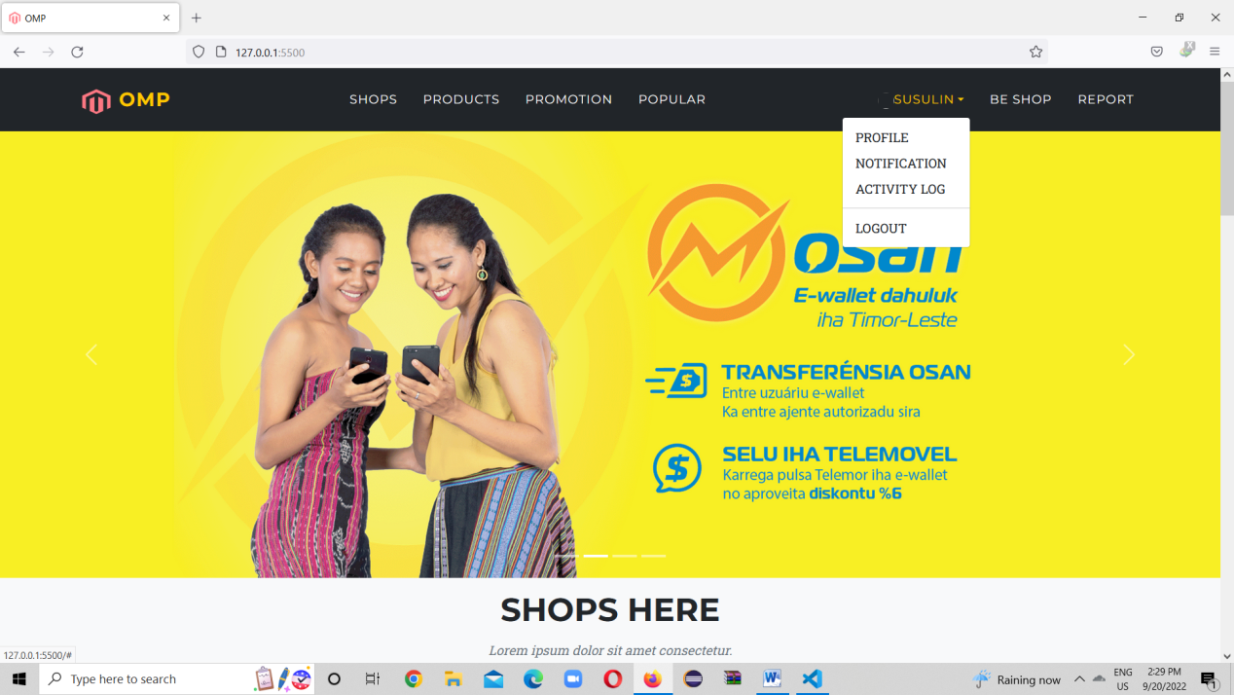

**Figure(5.3) : Customer Profile**

**(6) Be Shop Page**

When the customer clicks the Be Shop Button, a shop register form for shop owner is appear.

After the customer has filled the data, the customer can be a shop owner.

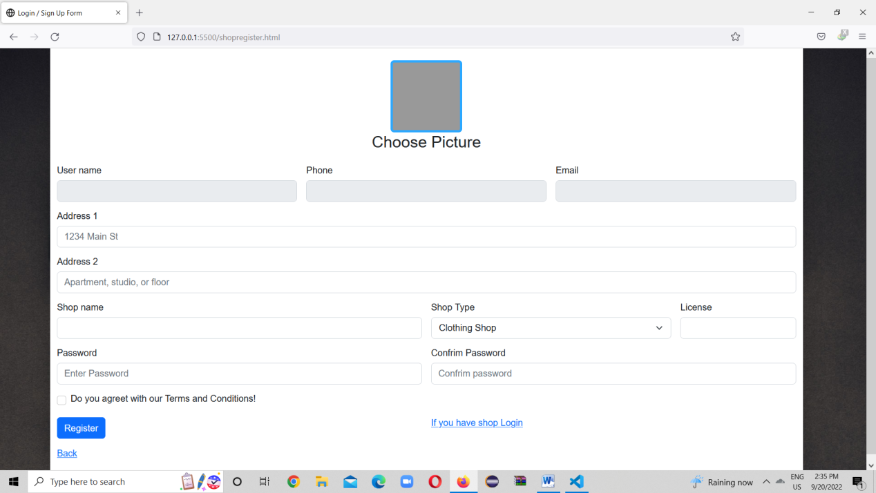

**Figure(6.1) : Shop Register Form**

If the customer has already account, the customer can login to their having account.

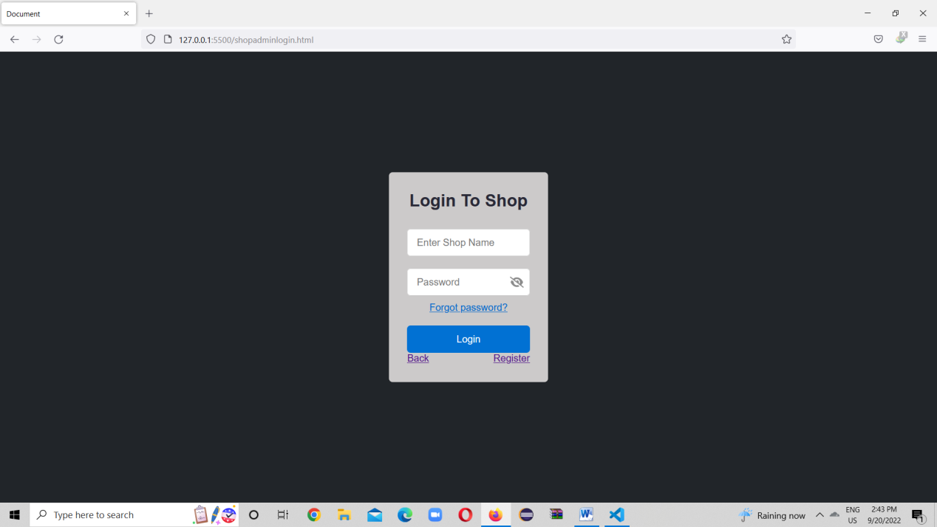

**Figure(6.2) : Shop Login Form**

**(7) Shop Admin View Page**

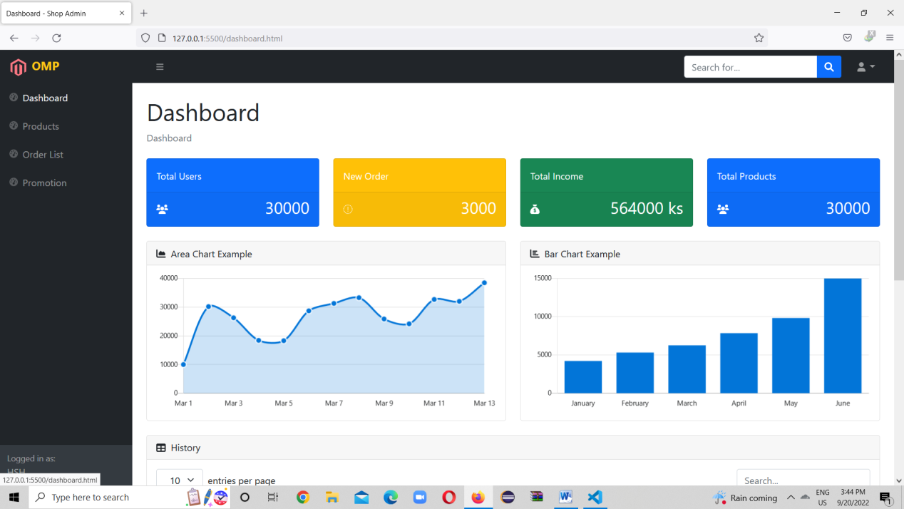

**Figure(7.1) : About Shop Admin View**

When the shop admin clicks the Products Button, the shop admin can create the new products, can update and delete the products, can be active and unactive for being products.

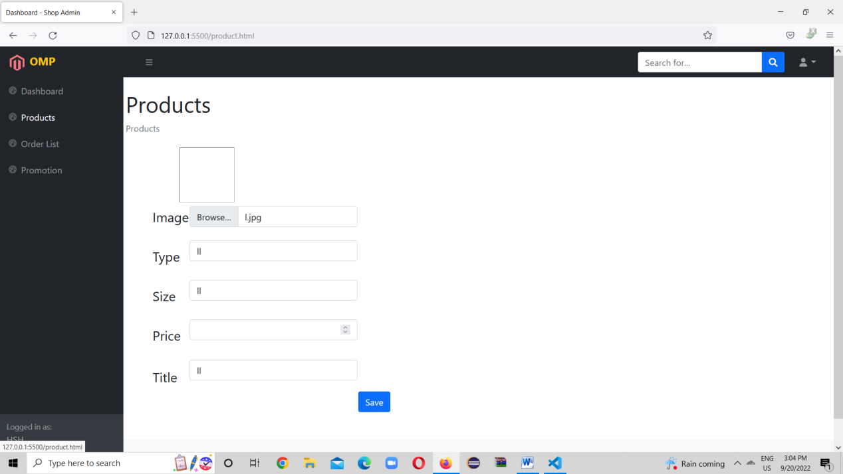

**Figure(7.2) : Product Create Page**

When the shop owner creates new products, there will be two buttons (Active and Unactive) under the product.

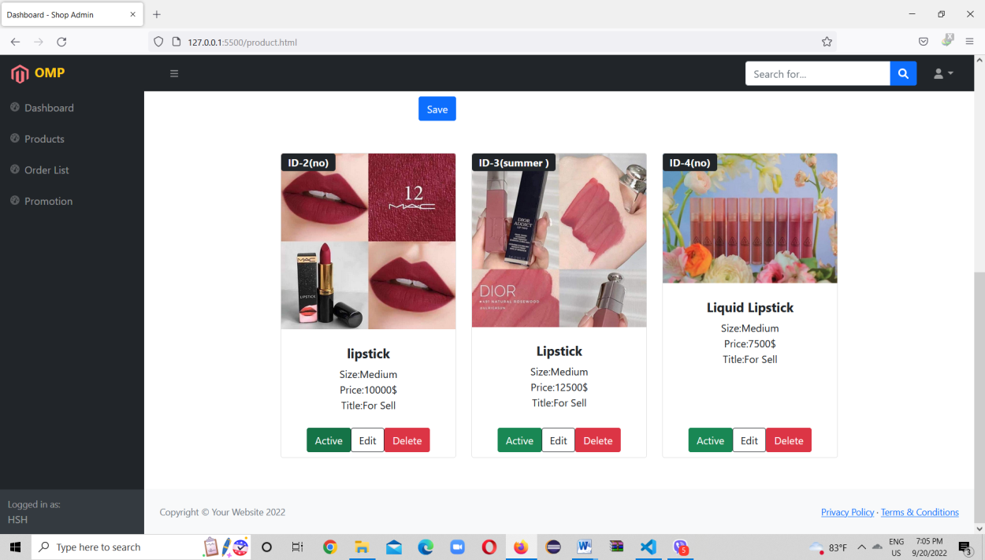

**Figure(7.3) : Products After Creating**

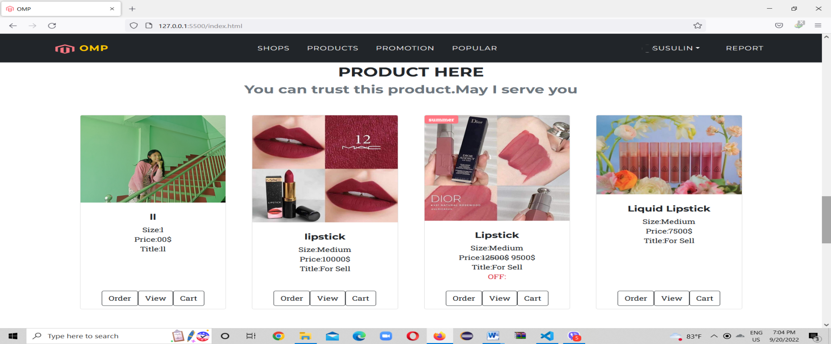If the shop owner clicks the Active Button, the created product will appear on the Home Page of the website.

**Figure(7.4) : Customer View’s Product**

If the shop owner clicks the Unactive Button, the activated product will disappear on the Home Page of the website.

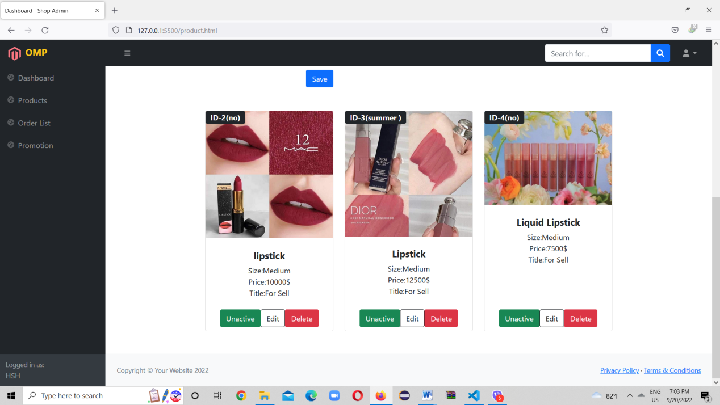

**Figure(7.5) : Shop Admin View**

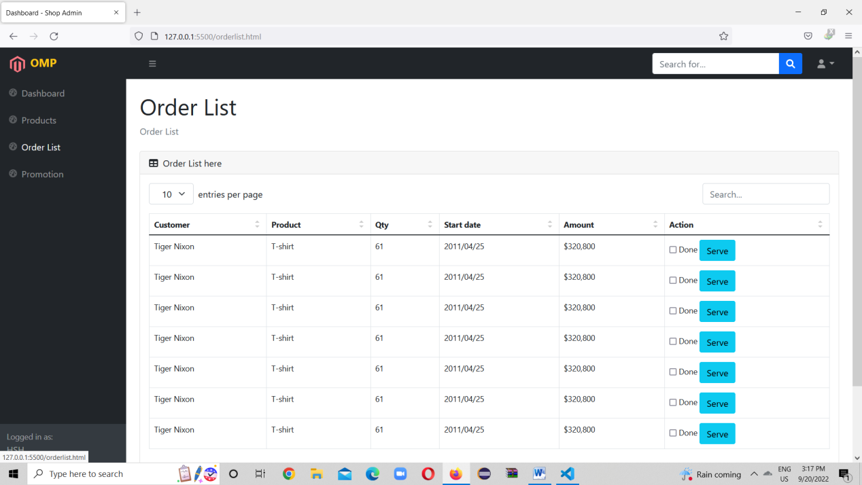When the shop owner clicks the Order List Button, the order list is shown in table.

**Figure(7.6) : Order List Table**

When the shop owner clicks the Promotion button, they can search the products what they want to promote with ID, can specify the products price, start date and end dates.

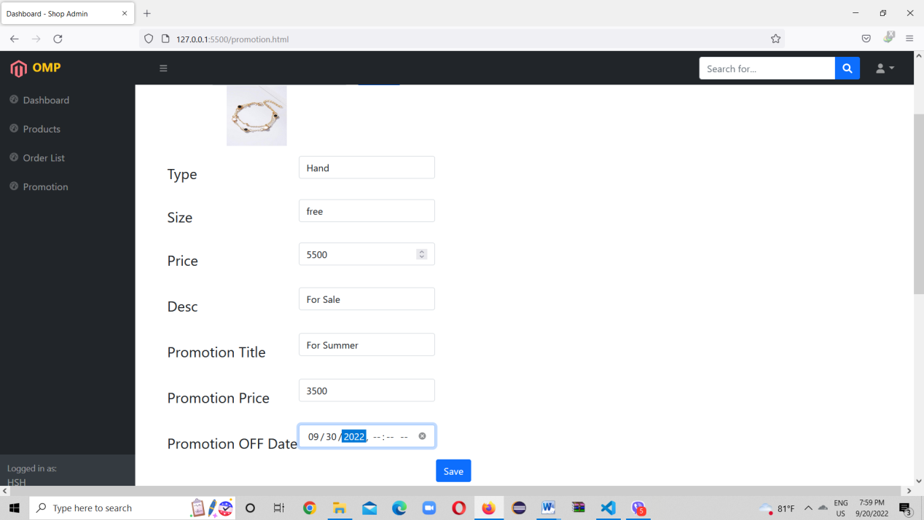When the shop owner clicks the Promotion Button, they can search the products what they want to promote with ID, can specify the products price, start date and end dates.

**Figure(7.7) : Promotion Form**

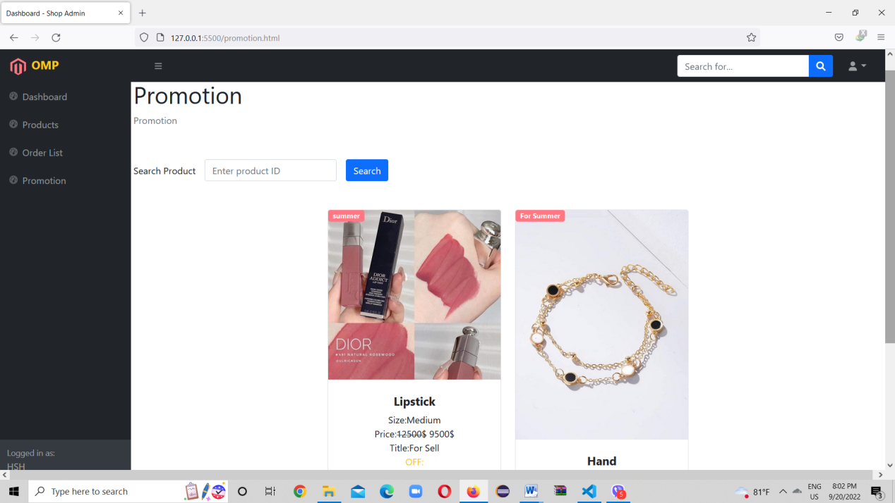

**Figure(7.8) : Promoted Products**

**(8) Report Page**

When the customer clicks the Report button, the customer can report about the products, shops.

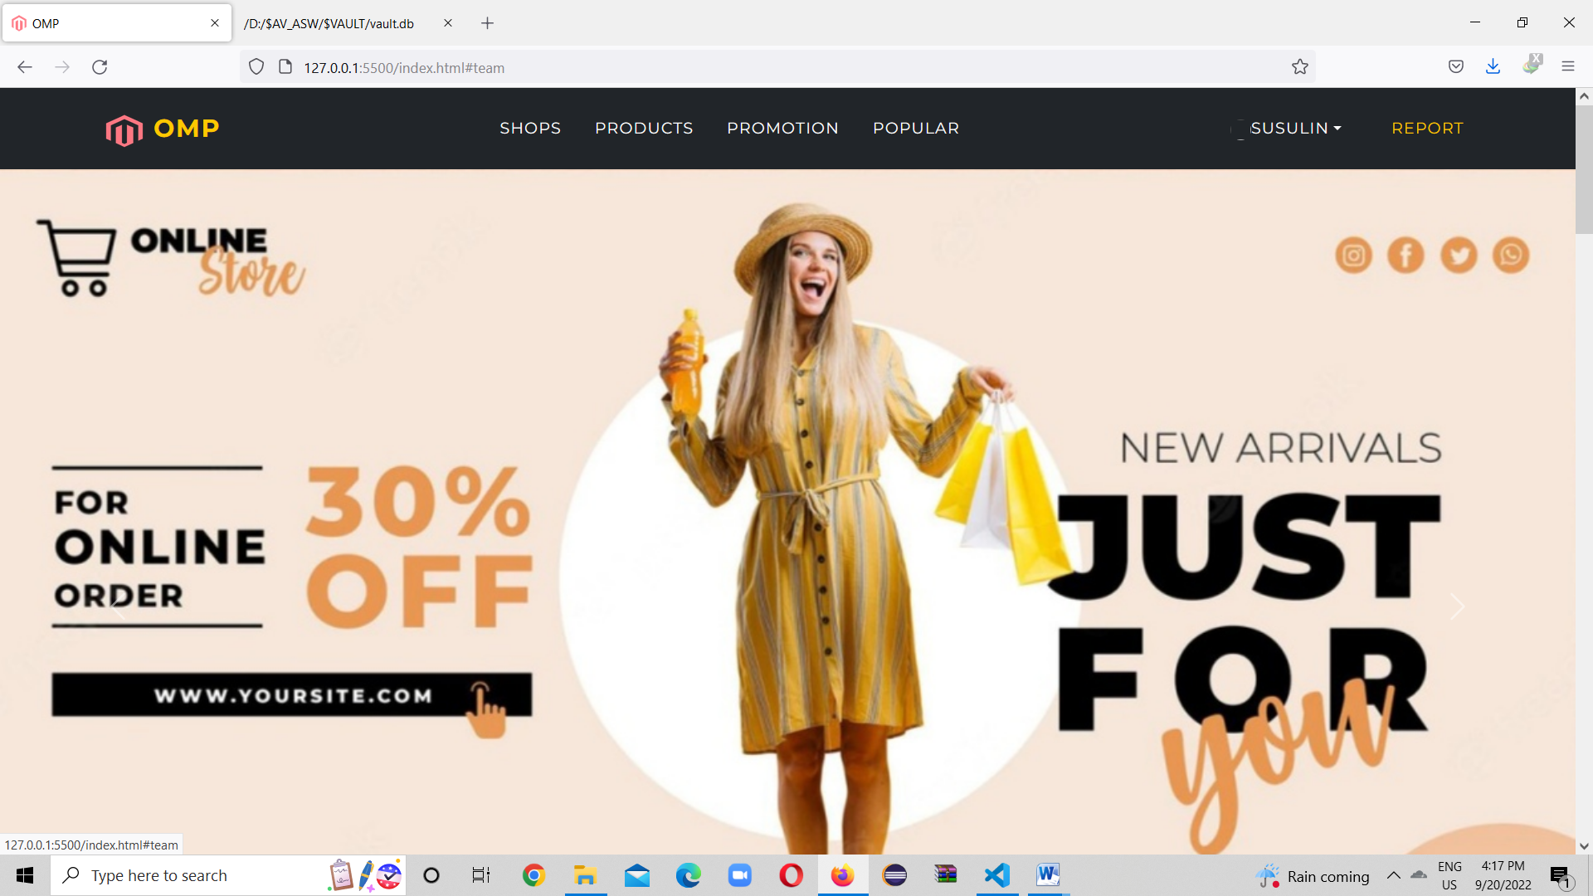

**Figure(8.1) : Report Page**

**CONCLUSION**

The Online Market Place (OMP) is designed to meet the requirements of online shopping system. This project has been developed in HTML, CSS, JSP, JS, J2EE and database built in MySQL server keeping in the specifications of the system. Using this system makes the customers and sellers can save energy and reduce waste times and no need to worry about product quality and prices. Products are explained in this website.

With this online system, ordering and viewing the products will be easier and systematic to replace traditional system where are still going to market for their purchasing. We believed that we accomplished our goals and satisfied with the code we developed and also purpose to be popular online shopping in the future.

The weak points of this website can’t access by anyone who has no internet connection. For the customer who wants to check the product quality is not suitable with this website.

Web Admin role and ordering will be added in the future. In addition, we will extend shop quantities, arrange for giving customers’ rating, reviews and reports about website and shops, giving promotion, popularity of products per month and order lists of products.

**REFERENCES**

**[1] https://getbootstrap.com/**

**[2] https://sweetalert.js.org/**

**[3] https://www.mysql.com/**

**[4] https://www.figma.com/**

**[5] https://www.w3schools.com/**

**[6] https://www.facebook.com/**